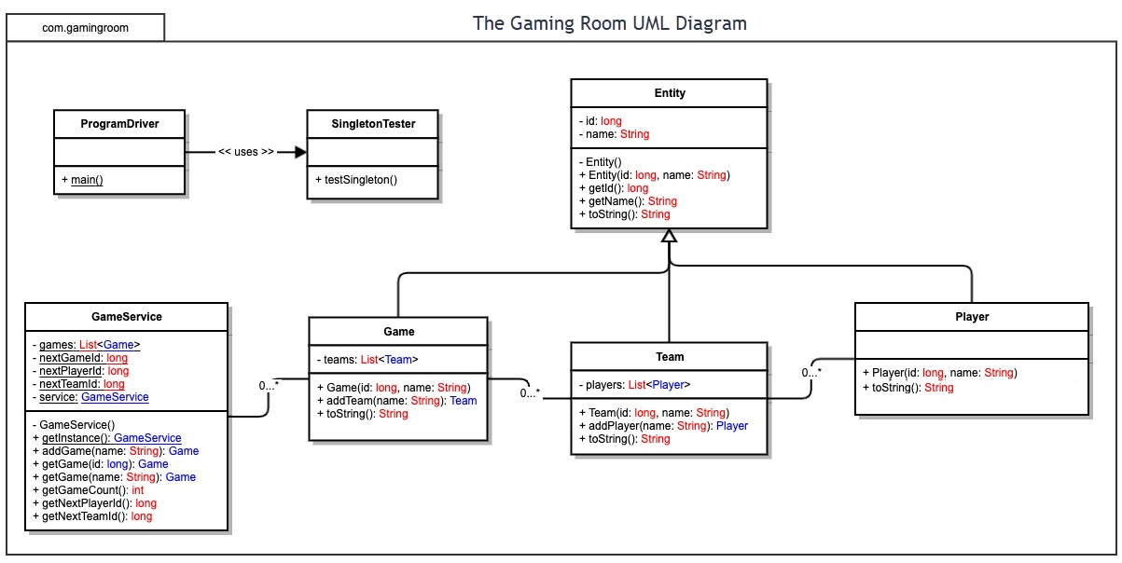
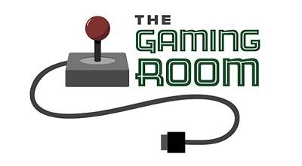

<Draw It or Lose It>

CS 230 Project Software Design
Version 1.0

Table of Contents

1.CS 230 Project Software Design Template 1
Table of Contents 2
Document Revision History 2
Executive Summary 3
Requirements 3
Design Constraints 3
System Architecture View 3
Domain Model 3
Evaluation 4
Recommendations 5
2.Operating Platform: <Recommend an appropriate operating platform that will allow The Gaming Room to expand Draw It or Lose It to other computing environments.> 5
3.Operating Systems Architectures: <Describe the details of the chosen operating platform architectures.> 5
4.Storage Management: <Identify an appropriate storage management system to be used with the recommended operating platform.> 5
5.Memory Management: <Explain how the recommended operating platform uses memory management techniques for the Draw It or Lose It software.> 5
6.Distributed Systems and Networks: <Knowing that the client would like Draw It or Lose It to communicate between various platforms, explain how this may be accomplished with distributed software and the network that connects the devices. Consider the dependencies between the components within the distributed systems and networks (connectivity, outages, and so on).> 5
7.Security: <Security is a must-have for the client. Explain how to protect user information on and between various platforms. Consider the user protection and security capabilities of the recommended operating platform.> 5

Document Revision History

Version | Date | Author | Comments
1.0 | 7/15/23 | Alexis Prazak | Covering the executive summary and system overview.
2.0 | 8/18/23 | Alexis Prazak | Added recommendations for game platform and storage solutions under recommendations.

Instructions
Fill in all bracketed information on page one (the cover page), in the Document Revision History table, and below each header. Under each header, remove the bracketed prompt and write your own paragraph response covering the indicated information.

Executive Summary

The gaming room wants to create a game where players compete in a picture guessing game. There is already a version of this game that is playable on Android devices. The challenge here is to create a version of the game that runs on a web-based application that can play with those using Android. The Java programming language is being used to create the bulk of the program. To extend the functionality of the program procedures for different devices to communicate will have to be created.

Requirements

There are five main requirements for this software.
- Teams will have one or more team involved per game.
- The game should support interactions between players on the web and android app.
- Only one instance of the game can exist in memory at any given time.
- Teams will have multiple players assigned to it.
- Game and team names must be unique to allow users to check whether a name is in use when choosing a team name.

Design Constraints

The game must run on a web-based application. It must perform the same functions as the android app. This includes pulling from the same set of images, setting a timer, and managing player interactions. Players using different harder will also need to be able to interact with each other. Any design will have to consider what API it will use to handle cross platform play. Modern users will expect a seamless experience with teammates.

System Architecture View

Please note: There is nothing required here for these projects, but this section serves as a reminder that describing the system and subsystem architecture present in the application, including physical components or tiers, may be required for other projects. A logical topology of the communication and storage aspects is also necessary to understand the overall architecture and should be provided.

Domain Model

The UML diagram begins with the program driver. The only thing currently connected is the singleton tester. Using the singleton design pattern ensures a player only runs a single instance of the game at a time. Next to that is the Entity class. Entity connects to the other game functions as follows.
- Game Service: This contains a bulk of the games function. One of its major functions is to use the getInstance function to see if a game has already been started. It also checks for the next players, next team, and gets their information. It is the only one in this list of classes that doesn’t directly communicate with the entity class.
- Game: This controls the Team list and will identify the game being played.
- Team: The main purpose of this function is to add individual users to the team they’ll be playing on. The game class will take teams from this function and add it to the Team list.
- Player: This class handles the individuals that make up a team. This is kept separate from the team class to keep the code clean.

Evaluation

Using your experience to evaluate the characteristics, advantages, and weaknesses of each operating platform (Linux, Mac, and Windows) as well as mobile devices, consider the requirements outlined below and articulate your findings for each. As you complete the table, keep in mind your client’s requirements and look at the situation holistically, as it all has to work together.

In each cell, remove the bracketed prompt and write your own paragraph response covering the indicated information.

Development Requirements | Mac | Linux | Windows | Mobile Devices
Server Side | The biggest disadvantage is Mac servers cannot be installed on Windows or Linux computers. Specialized hardware may need to be purchased to maintain the server. | The main advantage of Linux is its flexibility. It can also be relatively low cost thanks to the amount of open source software available to Linux users. | The primary server system used for Windows is developed by Microsoft. It is a reputable company with lots of support for businesses.  Windows applications can be hosted using serverless service providers, like AWS. | The largest advantage mobile devices have is the ability to connect from anywhere. However they tend to have less processing power when compared to other devices.
Client Side | <Determine the software development considerations (cost, time, expertise) that are necessary for supporting multiple types of clients as they pertain to Mac.> | <Determine the software development considerations (cost, time, expertise) that are necessary for supporting multiple types of clients as they pertain to Linux.> | <Determine the software development considerations (cost, time, expertise) that are necessary for supporting multiple types of clients as they pertain to Windows.> | <Determine the software development considerations (cost, time, expertise) that are necessary for supporting multiple types of clients as they pertain to Mobile Devices.>
Development Tools | <Identify the relevant programming languages and tools (IDEs and other tools) that are used to build this type of software for deploying on Mac.> | <Identify the relevant programming languages and tools (IDEs and other tools) that are used to build this type of software for deploying on Linux.> | <Identify the relevant programming languages and tools (IDEs and other tools) that are used to build this type of software for deploying on Windows.> | <Identify the relevant programming languages and tools (IDEs and other tools) that are used to build this type of software for deploying on Mobile Devices.>

Recommendations

The following recommendations are geared towards making Draw It or Lose It run as smoothly as possible. Performance, security, price, and infrastructure are considered. Thought was also put into what would be necessary for The Gaming Room to expand it to other platforms.
Operating Platform:
Windows is the ideal operating platform for Draw It or Lose It to start with. An estimated 74% of PCs worldwide run on Windows (Bonderud). This makes it the ideal platform to grow a robust user base on multiple devices, from desktop computers to tablets. An app created using the .NET core framework can be easily used on platforms like Linux and MacOS. This will decrease the changes needed when the game moves to another platform.
Operating Systems Architectures:
Windows uses what they call an NT Kernel. This kernel has been in use for multiple iterations of Windows. This makes it a stable choice. Applications communicate with the system hardware through an API, which writes and reads the application data(Norberg, 2000). NetBIOS is an API commonly used on Windows to transmit bits across the network. NetBIOS is the standard way to transmit bits between applications. Using this common form of communication will make it easier to work with other operating platforms.
Storage Management:
Creating a NoSQL with Amazon Web Services is my recommendation to the Gaming Room. NoSQL databases categorize data based on their relationship to each other. They are highly flexible and make expanding them simple (Menegasso, 2018). Using AWS will allow Draw It or Lose It to scale the number of players, games, and various pieces of data with ease. Services can be billed based on how much is used. This prevents the software from running out of storage space at a critical moment.
Memory Management:
Windows dedicates a portion of its memory to “virtual address space”. This space holds references to the actual location of the data. This makes it quicker for the computer to access. Cataloging items prevents the process of searching the entirety of a device’s memory. Please see the citations for Microsoft’s documentation regarding virtual memory management (Alvinashcraft).
Distributed Systems and Networks:
Distributed systems can help prevent issues like outages since the service doesn’t rely on a single piece of equipment to run. They are more reliable due to the workload being spread over multiple servers and computers. It can even speed up the software through parallel processing, where multiple processes run simultaneously. Services such as Amazon Web Services have made it possible to set up a distributed network simply by paying for their service.
Security:
To ensure security devices on all platforms should adhere to the same security requirements. It is worth educating players on how to accomplish these tasks. Most cases of user accounts being hacked come from human error, not an elite programmer breaking down a firewall. This education can be done by password length requirements, encouraging two-factor identification, and general security information given to the user.
Using distributed systems can increase security risks. This is due to the larger number of devices in the network. SSL certificates can be used to keep user data encrypted(Stouffer). It's important to remember security needs are ever-changing. Any security features Draw IT or Lose It implements should be reviewed on a regular basis.
Citations
Alvinashcraft. (n.d.). Virtual address space (memory management). Win32 apps | Microsoft Learn. https://learn.microsoft.com/en-us/windows/win32/memory/virtual-address-space
Bonderud, D. (n.d.). Cross-platform desktop applications: What are they, how they’re built, and where they excel. Spiceworks. https://www.spiceworks.com/tech/devops/articles/all-about-cross-platform-desktop-applications
Menegasso, A. E. (2018). NoSQL Overview from AWS. Amazon. https://aws.amazon.com/nosql/
Norberg, S. (2000). Windows NT/2000 Security. In Securing Windows NT. essay, O’Reilly Media, Inc.

Stouffer, C. (n.d.). What is an SSL certificate? A definition + faqs answered. United States. https://us.norton.com/blog/how-to/what-is-an-ssl-certificate

